Experiment No 10

AIM: To perform Port, Service monitoring, Windows/Linux server monitoring using Nagios.

Output-
Step 1: To Confirm that Nagios is running on the server side, run this sudo systemctl status nagios on the “NAGIOS HOST”.
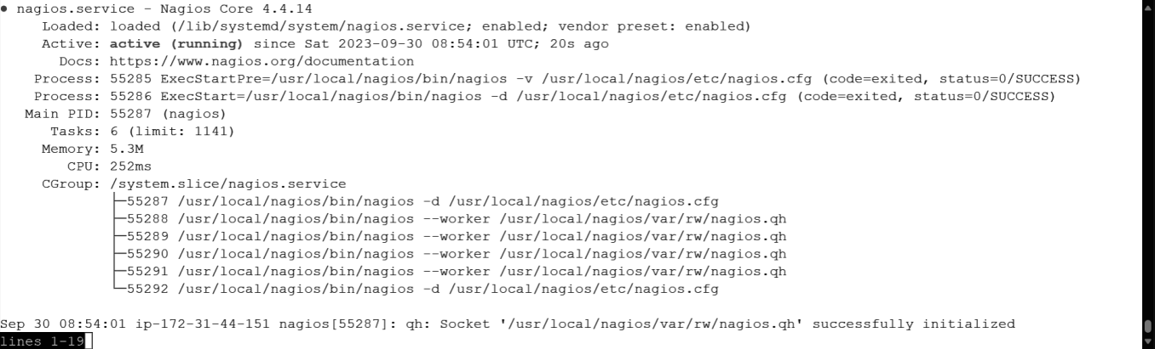

Step 2: To monitor a Linux machine, create an Ubuntu 20.04 server EC2 Instance in AWS.
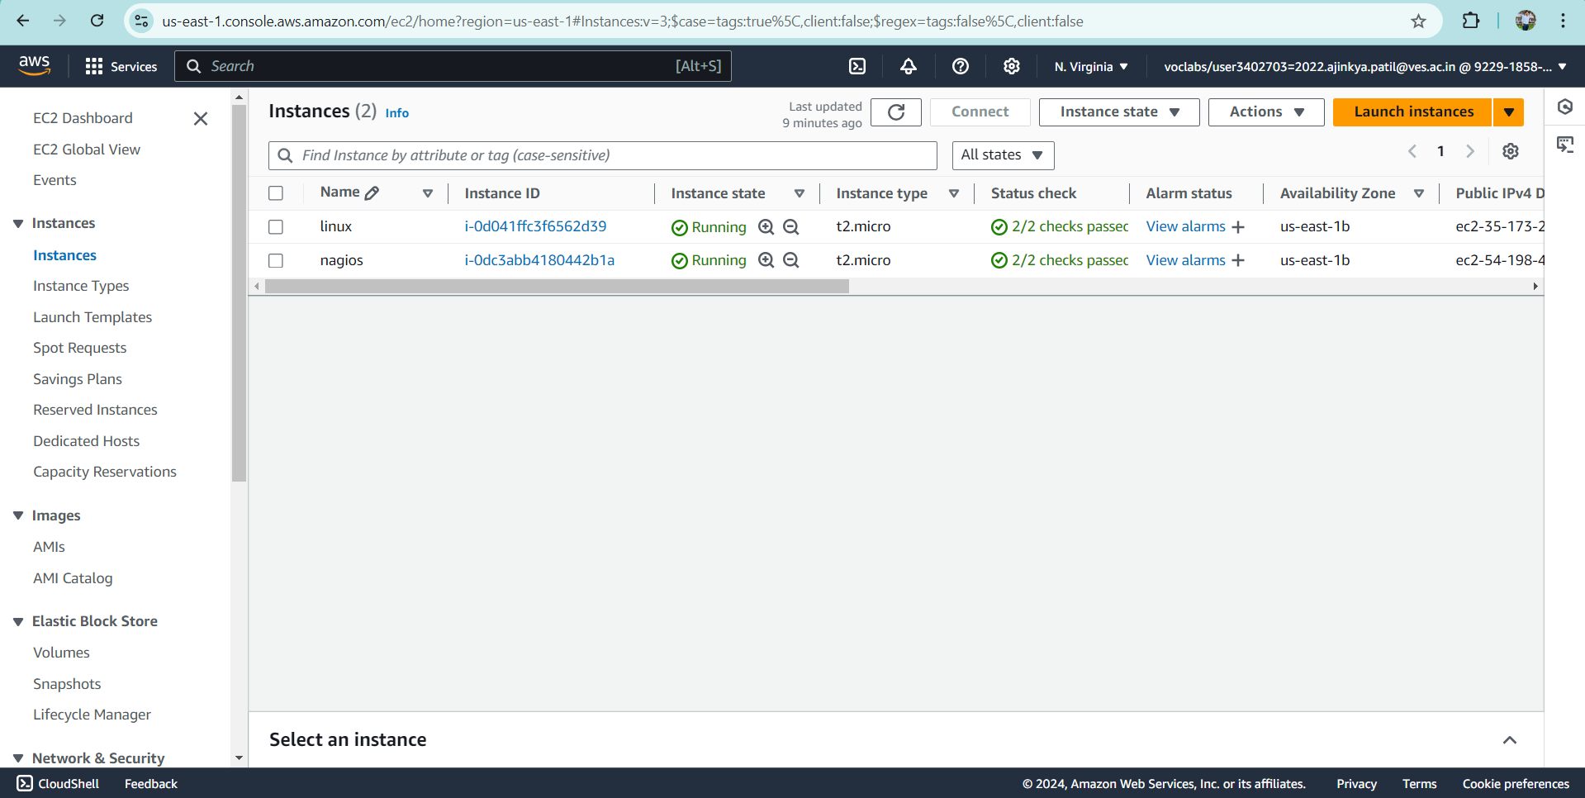

Step 3: On client side Step-03 Make a package index update and install gcc, nagios-nrpe-server and the plugins.
sudo apt update -y
sudo apt install gcc -y
sudo apt install -y nagios-nrpe-server nagios-plugins
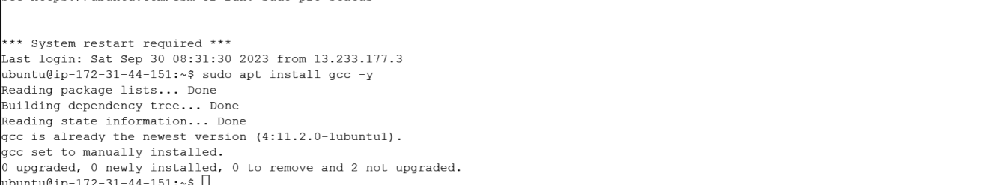
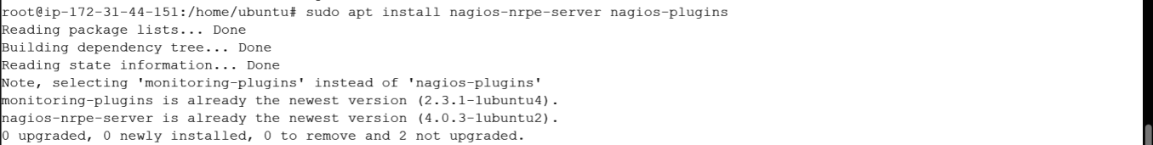

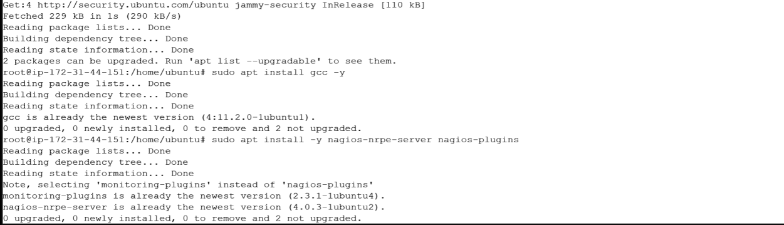
Step 4: Open nrpe.cfg file to make changes.
sudo nano /etc/nagios/nrpe.cfg
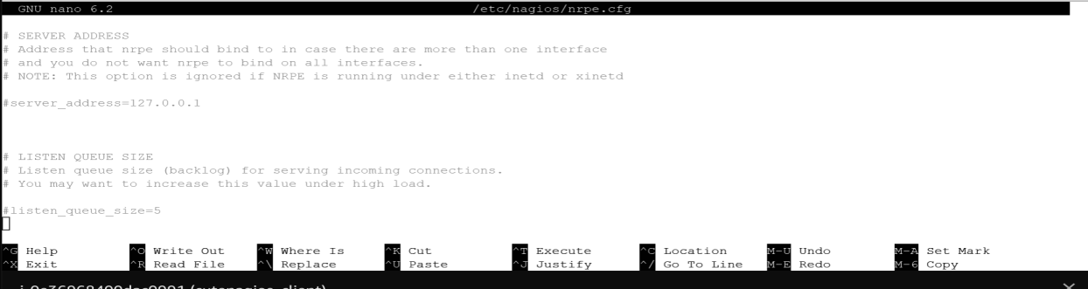
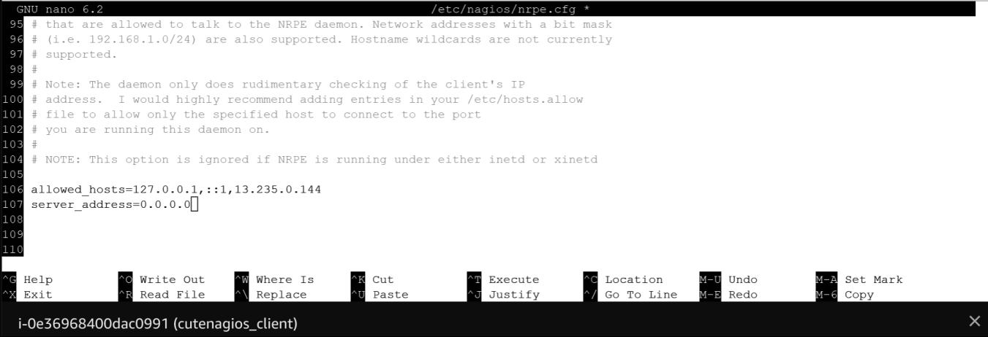

Step 5: Restart the NRPE server
sudo systemctl restart nagios-nrpe-server
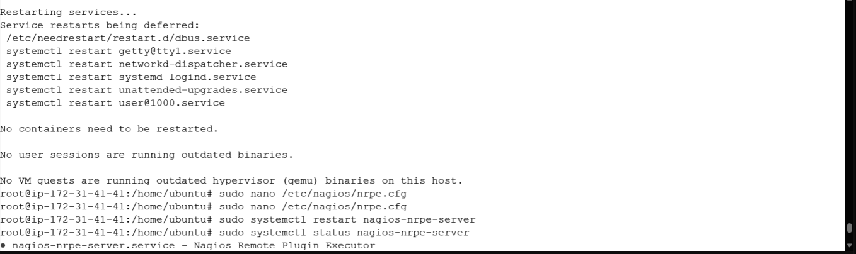
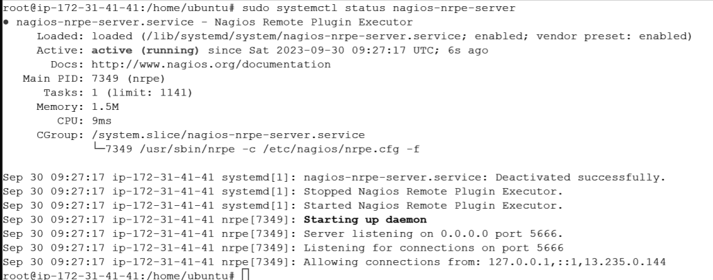
Step 6: On the server run this command
ps -ef | grep nagios
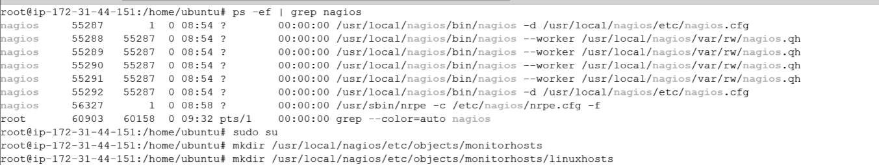

Step 7: Become a root user and create 2 folders 1.sudo su 2.mkdir /usr/local/nagios/etc/objects/monitorhosts 3.mkdir /usr/local/nagios/etc/objects/monitorhosts/linuxhosts Copy the sample localhost.cfg file to linuxhost folder 4.cp /usr/local/nagios/etc/objects/localhost.cfg /usr/local/nagios/etc/objects/monitorhosts/linuxhosts/linuxserver.cfg
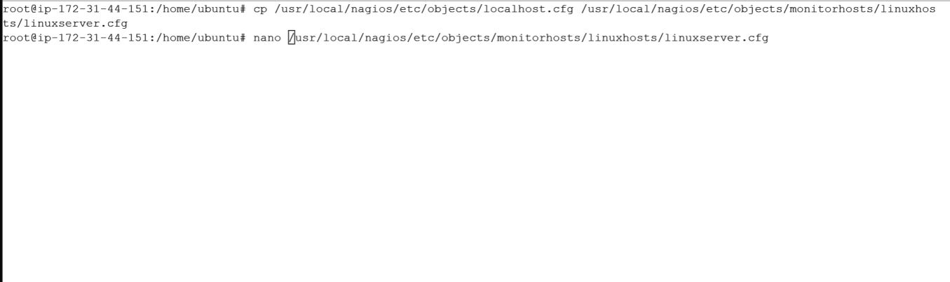

Step 8: Open linuxserver.cfg using nano and make the following changes
nano /usr/local/nagios/etc/objects/monitorhosts/linuxhosts/linuxserver.cfg Change the hostname to linux server (EVERYWHERE ON THE FILE) Change address to the public IP address of your LINUX CLIENT.
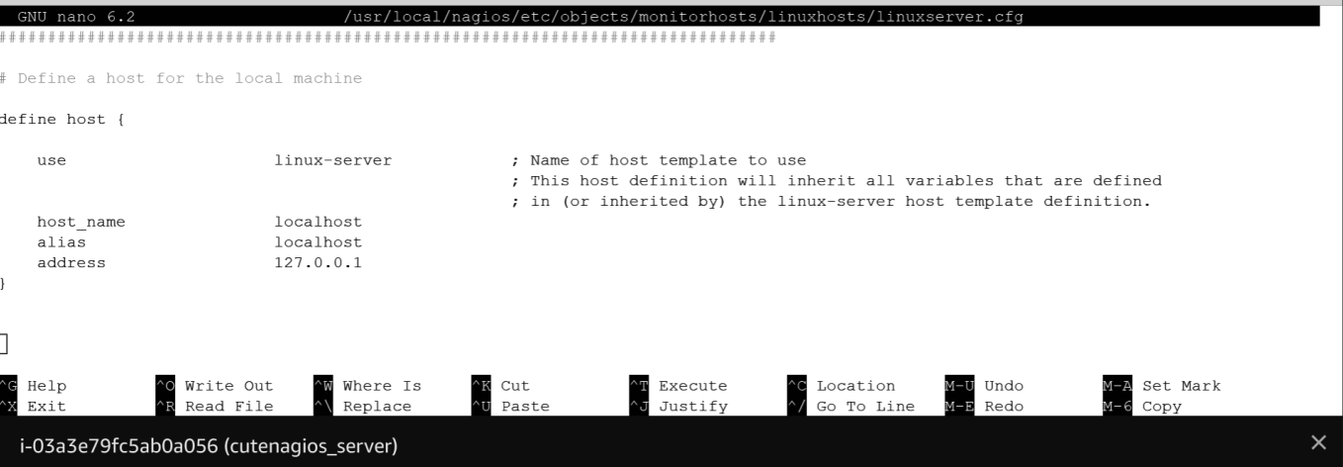
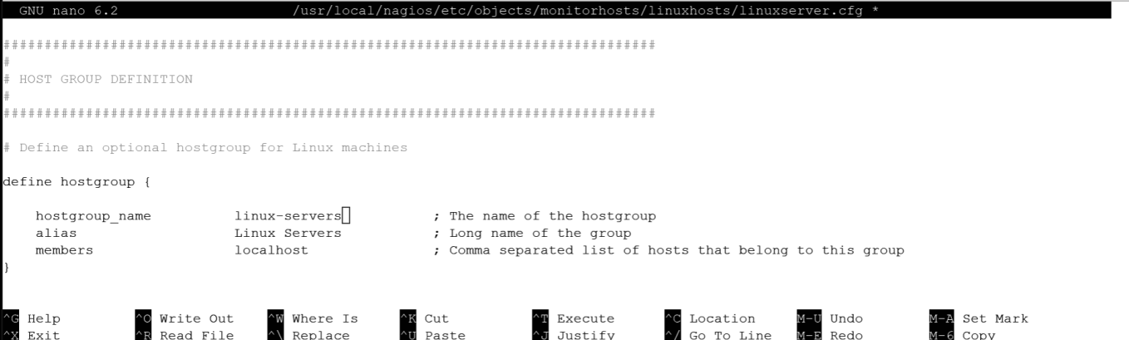
Change hostgroup_name under hostgroup to linux-servers1

Step 9: Open the Nagios Config file and add the following line nano /usr/local/nagios/etc/nagios.cfg Add this line cfg_dir=/usr/local/nagios/etc/objects/monitorhosts/

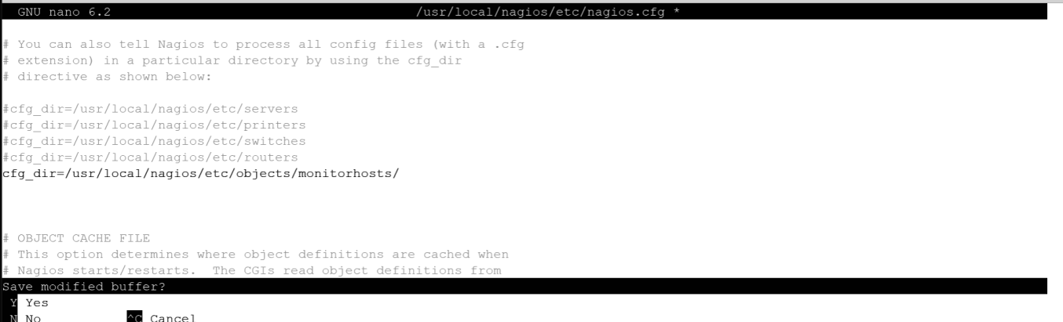

Step 10: Verify the configuration files.
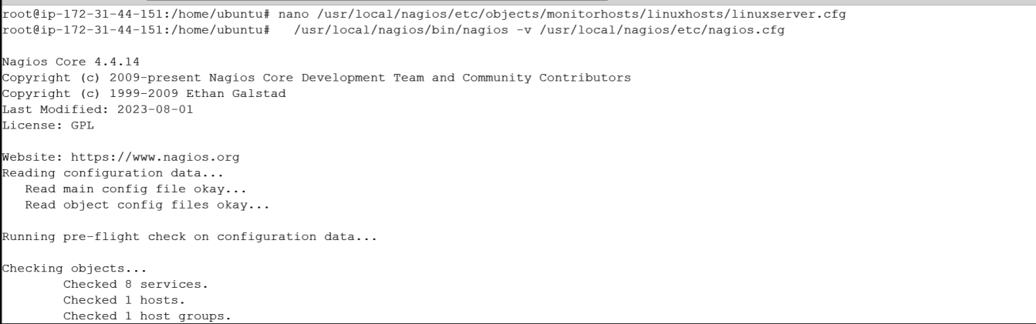
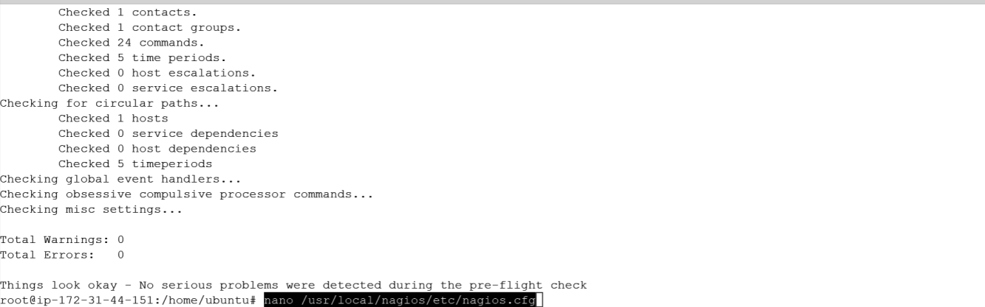
Step 11: Restart the nagios service service nagios restart
Sudo systemctl status nagios
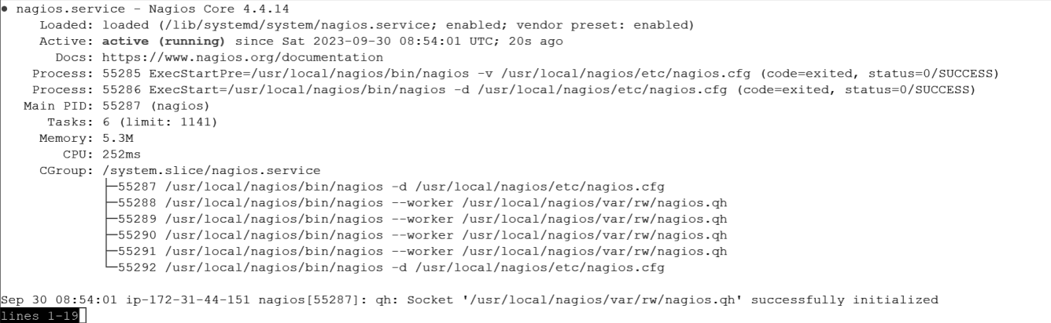

Step 12: Now, check your nagios dashboard and you’ll see a new host being added.
